EXERCISE – 08 (K-NEAREST NEIGHBORS)
1. AIM
To implement K-Nearest Neighbors (KNN) classification for heart disease prediction, compare several values of K and select the best-performing K.
2. ALGORITHM
1. Load the dataset and separate the features from the target Heart Disease.
2. Identify the numerical and categorical features.
3. Split the dataset into training and testing sets with stratification.
4. Scale the numerical features and one-hot encode the categorical features.
5. Train a KNN classifier for K = 1, 3, 5, 7, 9, 11, 15 and 21.
6. Calculate accuracy, precision, recall and F1 score for every K and plot them.
7. Select the best K and evaluate the final model using the confusion matrix, specificity and AUC.
3. PROGRAM
import pandas as pd
import numpy as np
import matplotlib.pyplot as plt
import seaborn as sns
from sklearn.model_selection import train_test_split
from sklearn.preprocessing import StandardScaler
from sklearn.compose import ColumnTransformer
from sklearn.preprocessing import OneHotEncoder
from sklearn.neighbors import KNeighborsClassifier
from sklearn.metrics import (
accuracy_score,
precision_score,
recall_score,
f1_score,
confusion_matrix,
classification_report,
roc_curve,
roc_auc_score
)
df = pd.read_csv("heart_disease_dataset.csv")
print("Dataset Shape:", df.shape)
print("\nFirst 5 Records:")
print(df.head())
print("\nDataset Information:")
print(df.info())
print("\nMissing Values:")
print(df.isnull().sum())
print("\nTarget Distribution:")
print(df["Heart Disease"].value_counts())
X = df.drop("Heart Disease", axis=1)
y = df["Heart Disease"]
numerical_features = X.select_dtypes(
include=["int64", "float64"]
).columns
categorical_features = X.select_dtypes(
include=["object"]
).columns
print("Numerical Features:")
print(list(numerical_features))
print("\nCategorical Features:")
print(list(categorical_features))
X_train, X_test, y_train, y_test = train_test_split(
X,
y,
test_size=0.20,
random_state=42,
stratify=y
)
print("Training Data:", X_train.shape)
print("Testing Data :", X_test.shape)
preprocessor = ColumnTransformer(
transformers=[
("num", StandardScaler(), numerical_features),
("cat", OneHotEncoder(handle_unknown="ignore"), categorical_features)
]
)
X_train_processed = preprocessor.fit_transform(X_train)
X_test_processed = preprocessor.transform(X_test)
K = 5
knn = KNeighborsClassifier(
n_neighbors=5
)
knn.fit(
X_train_processed,
y_train
)
y_pred = knn.predict(
X_test_processed
)
print("Predicted Values:")
print(y_pred[:20])
print(
classification_report(
y_test,
y_pred
)
)
k_values = [1, 3, 5, 7, 9, 11, 15, 21]
accuracy_values = []
precision_values = []
recall_values = []
f1_values = []
for k in k_values:
knn = KNeighborsClassifier(
n_neighbors=k
)
knn.fit(
X_train_processed,
y_train
)
y_pred = knn.predict(
X_test_processed
)
accuracy_values.append(
accuracy_score(
y_test,
y_pred
)
)
precision_values.append(
precision_score(
y_test,
y_pred
)
)
recall_values.append(
recall_score(
y_test,
y_pred
)
)
f1_values.append(
f1_score(
y_test,
y_pred
)
)
results = pd.DataFrame({
"K": k_values,
"Accuracy": accuracy_values,
"Precision": precision_values,
"Recall": recall_values,
"F1 Score": f1_values
})
print(results)
plt.figure(figsize=(8, 5))
plt.plot(
k_values,
accuracy_values,
marker="o"
)
plt.xlabel("K Value")
plt.ylabel("Accuracy")
plt.title("Effect of K Value on KNN Accuracy")
plt.xticks(k_values)
plt.grid()
plt.show()
best_index = np.argmax(f1_values)
best_k = k_values[best_index]
print("Best K:", best_k)
print(
"Best Accuracy:",
accuracy_values[best_index]
)
print(
"Best Precision:",
precision_values[best_index]
)
print(
"Best Recall:",
recall_values[best_index]
)
print(
"Best F1 Score:",
f1_values[best_index]
)
final_knn = KNeighborsClassifier(
n_neighbors=best_k
)
final_knn.fit(
X_train_processed,
y_train
)
final_pred = final_knn.predict(
X_test_processed
)
final_accuracy = accuracy_score(
y_test,
final_pred
)
final_precision = precision_score(
y_test,
final_pred
)
final_recall = recall_score(
y_test,
final_pred
)
final_f1 = f1_score(
y_test,
final_pred
)
final_cm = confusion_matrix(
y_test,
final_pred
)
TN, FP, FN, TP = final_cm.ravel()
final_specificity = TN / (TN + FP)
final_probability = final_knn.predict_proba(
X_test_processed
)[:, 1]
final_auc = roc_auc_score(
y_test,
final_probability
)
print("\n======================================")
print("FINAL KNN MODEL")
print("======================================")
print("Best K :", best_k)
print("Accuracy :", final_accuracy)
print("Precision :", final_precision)
print("Recall :", final_recall)
print("F1 Score :", final_f1)
print("Specificity :", final_specificity)
print("AUC :", final_auc)

4. OUTPUT
The program was executed on the Heart disease dataset (heart_disease_dataset.csv) and produced the following output:
Dataset Shape: (1000, 16)
First 5 Records:
Age Gender ... Chest Pain Type Heart Disease
0 75 Female ... Atypical Angina 1
1 48 Male ... Typical Angina 0
2 53 Male ... Atypical Angina 1
3 69 Female ... Non-anginal Pain 0
4 62 Female ... Asymptomatic 0
[5 rows x 16 columns]
Dataset Information:
<class 'pandas.core.frame.DataFrame'>
RangeIndex: 1000 entries, 0 to 999
Data columns (total 16 columns):
# Column Non-Null Count Dtype
--- ------ -------------- -----
0 Age 1000 non-null int64
1 Gender 1000 non-null object
2 Cholesterol 1000 non-null int64
3 Blood Pressure 1000 non-null int64
4 Heart Rate 1000 non-null int64
5 Smoking 1000 non-null object
6 Alcohol Intake 660 non-null object
7 Exercise Hours 1000 non-null int64
8 Family History 1000 non-null object
9 Diabetes 1000 non-null object
10 Obesity 1000 non-null object
11 Stress Level 1000 non-null int64
12 Blood Sugar 1000 non-null int64
13 Exercise Induced Angina 1000 non-null object
14 Chest Pain Type 1000 non-null object
15 Heart Disease 1000 non-null int64
dtypes: int64(8), str(8)
memory usage: 125.1 KB
None
Missing Values:
Age 0
Gender 0
Cholesterol 0
Blood Pressure 0
Heart Rate 0
Smoking 0
Alcohol Intake 340
Exercise Hours 0
Family History 0
Diabetes 0
Obesity 0
Stress Level 0
Blood Sugar 0
Exercise Induced Angina 0
Chest Pain Type 0
Heart Disease 0
dtype: int64
Target Distribution:
Heart Disease
0 608
1 392
Name: count, dtype: int64
Numerical Features:
['Age', 'Cholesterol', 'Blood Pressure', 'Heart Rate', 'Exercise Hours', 'Stress Level', 'Blood Sugar']
Categorical Features:
['Gender', 'Smoking', 'Alcohol Intake', 'Family History', 'Diabetes', 'Obesity', 'Exercise Induced Angina', 'Chest Pain Type']
Training Data: (800, 15)
Testing Data : (200, 15)
Predicted Values:
[1 0 0 0 1 0 1 1 0 0 0 0 0 0 1 1 1 0 0 1]
precision recall f1-score support
0 0.90 0.87 0.88 122
1 0.80 0.85 0.82 78
accuracy 0.86 200
macro avg 0.85 0.86 0.85 200
weighted avg 0.86 0.86 0.86 200
K Accuracy Precision Recall F1 Score
0 1 0.795 0.740260 0.730769 0.735484
1 3 0.885 0.866667 0.833333 0.849673
2 5 0.860 0.804878 0.846154 0.825000
3 7 0.885 0.866667 0.833333 0.849673
4 9 0.875 0.853333 0.820513 0.836601
5 11 0.905 0.915493 0.833333 0.872483
6 15 0.900 0.902778 0.833333 0.866667
7 21 0.900 0.902778 0.833333 0.866667
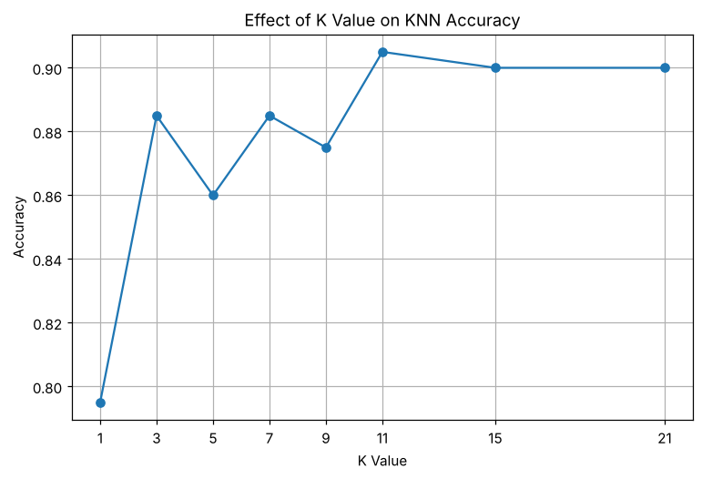
Best K: 11
Best Accuracy: 0.905
Best Precision: 0.9154929577464789
Best Recall: 0.8333333333333334
Best F1 Score: 0.87248322147651
======================================
FINAL KNN MODEL
======================================
Best K : 11
Accuracy : 0.905
Precision : 0.9154929577464789
Recall : 0.8333333333333334
F1 Score : 0.87248322147651
Specificity : 0.9508196721311475
AUC : 0.9550756620428752

5. RESULT
Thus, the K-Nearest Neighbors practical was implemented successfully. Among the K values tested, K = 11 gave the best performance, with an accuracy of 0.905, a precision of 0.9155, a recall of 0.8333, an F1 score of 0.8725 and an AUC of 0.9551.

